**QSMART – GRM ASSY**

**REPLACEMENT**

**PROCEDURE**

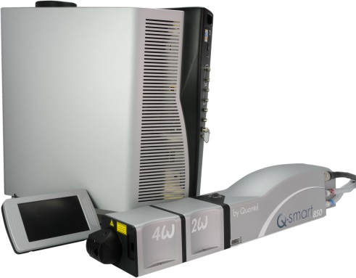

**Toolkit:**

Metric Allen Keys

Special tool for interlock cover head RM100016A

Special tool SM020006A for software update

Special tool (3/OUT/0478) for Gaussian alignment

Powermeter

Scope and photodiode

Burn paper

Ethernet cable

Target (at 43mm)

**System**: QSMART

|  |  |  |  |  |  |  |  |  |
| --- | --- | --- | --- | --- | --- | --- | --- | --- |
|  | | | | |  |  |  |  |
| |  |  |  |  |  |  |  | | --- | --- | --- | --- | --- | --- | --- | | |  |  | | --- | --- | | **SM010349** | **Q-SMART GRM ASSY** | |  |  |  |  | | | | | |  |  |  |  |
|  |  |  |  |
|  |

**Purpose**: This procedure describes the integration of Q-Smart GRM assy.

|  |  |  |
| --- | --- | --- |
| Revision | date | modification |
| Initial issue | July 4, 2014 |  |
|  |  |  |
|  |  |  |
|  |  |  |

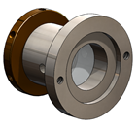

# DISASSEMBLING

* Turn the system off
* Disconnect cables and water hoses from the side of the laser head
* Remove the laser head cover.
* Remove the side plate (7 BHC 3x6)

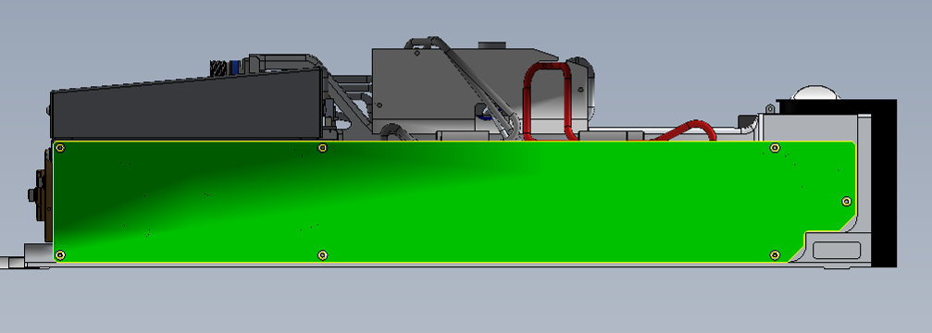

* Remove the front panel of the Laser head (unscrew the 6 CHC 3x10 screws and the 2 UNC 4-40 long ¼ 3/E13/0601 screws)

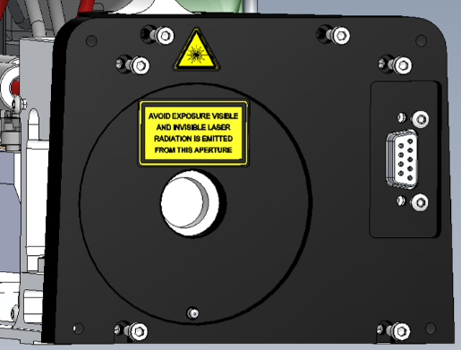

* Remove the GRM assy ( 3 screws CHC 4x12 + washers ZU4)

# INTEGRATION OF THE GAUSSIAN MIRROR

* Place the tool 3/OUT/ 0478 on the mechanical part of Gaussian mirror
* Fix the nut with an Allen key and turn the tool in order to tight the rotary part
* Block the Gaussian assy

Nut

(allen key in the hole)

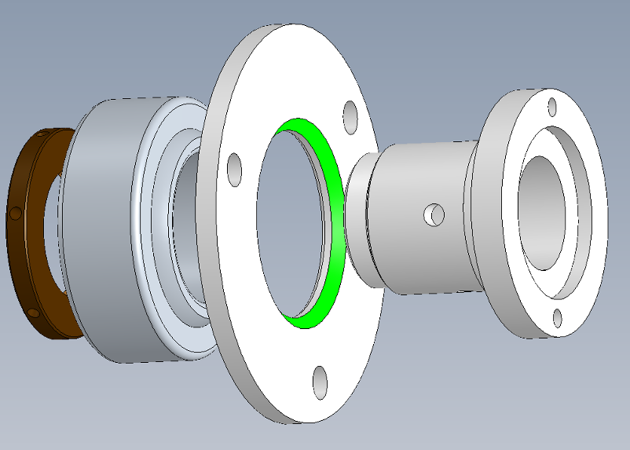

Place the tool 3/OUT/0478

Swivle bearing

# ALIGNMENT OF THE GAUSSIAN MIRROR

* Check the good alignment of the He-Ne beam with a target (near field and far field)

M1

Pin hole

He-Ne

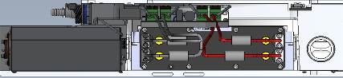



M2

Target

Bright Grm reflection

Diagram of Laser head (view from the top)

Rod reflection

Target

Rod

Gaussian Mirror

Face 1

Face 2

(wedge)

Incident He-Ne beam coming from M2

He-Ne incident

He-Ne reflected

Reflection of Gaussian mirror

(face 1)

* Screw lightly the 3 screws CHC 4x12 located on the mount of the Gaussian Mirror assy
* Turn the Gaussian mirror around the optical axis in order to place the two reflections on the same horizontal axis at 43mm. (Refer to the diagram)
* Stack the reflected beam of the face 1 (low light reflection) on the incident beam (it’s better to see on the pinhole), the other reflected beam have to stay on the line of sight at 43mm.
* (If there is a confusion between the two reflections of the Gaussian mirror, the HeNe beam not go through until the back mirror)??
* Tight the 3 screw of the gaussian mirror with a wrench key (5n m)
* With a hammer stack again the reflective beam by hitting the tool 3/OUT/0478.
* Remove the tool 3/OUT/0478
* Re-install the front panel of Laser head
* Close the Laser head and put warranty stickers   
  *Refer to "LH-Warranty Labels"*